**EXP-1:**

**Create a student registration form with HTML5 validation for name, email, and age inputs:**

<!DOCTYPE html>

<html lang="en">

<head>

<meta charset="UTF-8" />

<title>Student Registration Form</title>

<meta name="viewport" content="width=device-width, initial-scale=1.0"/>

<style>

body { font-family: sans-serif; background: #f4f4fa; }

form { max-width: 350px; margin: 2rem auto; background: #fff; padding: 1.5rem; border-radius: 8px; box-shadow: 0 2px 8px #0001; }

label, input { display: block; width: 100%; margin-bottom: 12px; }

input[type="submit"] { background: #3560f6; color: #fff; border: none; border-radius: 4px; padding: 10px; cursor: pointer; }

input[type="submit"]:hover { background: #233bb2; }

</style>

</head>

<body>

<form>

<h2>Student Registration</h2>

<label>Name

<input type="text" name="name" required pattern="[A-Za-z ]{3,}" title="Enter at least 3 alphabetic characters"/>

</label>

<label>Email

<input type="email" name="email" required />

</label>

<label>Age

<input type="number" name="age" required min="16" max="120" />

</label>

<input type="submit" value="Register"/>

</form>

</body>

</html>

**EXP-2:**

**Build a responsive banking UI with deposit/withdrawal buttons and balance display:**

<!DOCTYPE html>

<html lang="en">

<head>

<meta charset="UTF-8" />

<title>Bank UI</title>

<meta name="viewport" content="width=device-width, initial-scale=1.0"/>

<style>

body { font-family: sans-serif; background: #eaeef1; }

.bank-container {

max-width: 400px;

background: #fff;

margin: 3rem auto;

border-radius: 10px;

box-shadow: 0 2px 10px #0002;

padding: 2rem;

text-align: center;

}

.balance { font-size: 2rem; margin: 1rem 0; color: #3560f6; }

.btns input[type="number"] { width: 100px; margin-right: 1rem; }

.deposit, .withdraw {

background: #3560f6;

color: #fff; border: none; border-radius: 5px; padding: 8px 14px;

margin: 0.5rem;

cursor: pointer;

}

.withdraw { background: #f66c4f; }

@media (max-width: 520px) {

.bank-container { padding: 1rem; }

.btns { display: block; }

.btns > * { margin: 0.25rem auto; }

}

</style>

</head>

<body>

<div class="bank-container">

<h2>Your Account</h2>

<div class="balance" id="balance">$0.00</div>

<div class="btns">

<input type="number" id="amount" placeholder="Amount" min="1"/>

<button class="deposit" onclick="deposit()">Deposit</button>

<button class="withdraw" onclick="withdraw()">Withdraw</button>

</div>

<div id="message" style="margin-top: 1rem; color: #d64f3a;"></div>

</div>

<script>

let balance = 0;

function updateBalance() {

document.getElementById('balance').innerText = `$${balance.toFixed(2)}`;

}

function showMsg(msg, color) {

const msgDiv = document.getElementById('message');

msgDiv.style.color = color;

msgDiv.innerText = msg;

setTimeout(()=>msgDiv.innerText='',2000);

}

function deposit() {

let amt = Number(document.getElementById('amount').value);

if(amt > 0) {

balance += amt;

updateBalance();

showMsg('Deposit Successful', '#36ad6e');

} else {

showMsg('Enter a valid amount.', '#d64f3a');

}

document.getElementById('amount').value = '';

}

function withdraw() {

let amt = Number(document.getElementById('amount').value);

if(amt > 0 && amt <= balance) {

balance -= amt;

updateBalance();

showMsg('Withdrawal Successful', '#36ad6e');

} else if(amt > balance) {

showMsg('Insufficient funds.', '#d64f3a');

} else {

showMsg('Enter a valid amount.', '#d64f3a');

}

document.getElementById('amount').value = '';

}

updateBalance();

</script>

</body>

</html>

**EXP-3:**

## **Admin Dashboard with CSS Grid & Dynamic Theme Switching:**

<!DOCTYPE html>

<html lang="en">

<head>

<meta charset="UTF-8" />

<title>Admin Dashboard</title>

<meta name="viewport" content="width=device-width, initial-scale=1.0"/>

<style>

:root {

--bg: #f4f4fa;

--sidebar: #222b45;

--sidebar-text: #fff;

--main: #fff;

--accent: #3560f6;

--text: #1c1e21;

}

[data-theme="dark"] {

--bg: #181c23;

--sidebar: #233;

--sidebar-text: #c8cfff;

--main: #24273a;

--accent: #e9b96e;

--text: #f5f7fa;

}

body {

font-family: 'Segoe UI', sans-serif;

margin: 0; background: var(--bg); color: var(--text);

min-height: 100vh;

transition: background 0.3s, color 0.3s;

}

.dashboard {

min-height: 100vh; display: grid;

grid-template-areas:

"sidebar header"

"sidebar main";

grid-template-columns: 220px 1fr;

grid-template-rows: 60px 1fr;

}

.sidebar {

grid-area: sidebar;

background: var(--sidebar);

color: var(--sidebar-text);

padding: 1.5rem 1rem;

min-height: 0;

display: flex;

flex-direction: column;

gap: 1.5rem;

}

.sidebar h2 { color: var(--accent); font-size: 1.4rem; }

.sidebar a {

color: var(--sidebar-text); text-decoration: none;

padding: 0.4rem 0.8rem; border-radius: 4px;

}

.sidebar a.active, .sidebar a:hover { background: var(--accent); color: #fff; }

.header {

grid-area: header; background: var(--main);

display: flex;

align-items: center; justify-content: space-between;

padding: 0 1.5rem; box-shadow: 0 2px 4px #0001;

}

.main {

grid-area: main; background: var(--main);

padding: 2rem;

}

.main h1 { margin-top: 0; }

.dashboard-widgets {

display: grid; gap: 1.5rem;

grid-template-columns: repeat(auto-fit, minmax(200px, 1fr));

margin-top: 1.5rem;

}

.widget {

background: var(--bg); border-radius: 10px; padding: 1.2rem;

box-shadow: 0 2px 8px #0001;

}

.theme-toggle {

cursor: pointer; padding: 0.5rem 1.2rem;

border: none; border-radius: 6px;

background: var(--accent); color: #fff; font-size: 1rem;

transition: background .3s;

margin-left: 2rem;

}

@media (max-width: 800px) {

.dashboard { grid-template-areas: "header" "main" "sidebar"; grid-template-columns: 1fr; grid-template-rows: 60px 1fr auto;}

.sidebar { flex-direction: row; gap: 2rem; justify-content: center; }

.main { padding: 1rem;}

}

</style>

</head>

<body>

<div class="dashboard" id="dashboard">

<nav class="sidebar">

<h2>Admin</h2>

<a href="#" class="active">Dashboard</a>

<a href="#">Users</a>

<a href="#">Reports</a>

<a href="#">Settings</a>

</nav>

<header class="header">

<span>Admin Dashboard</span>

<button class="theme-toggle" onclick="toggleTheme()">🌙 / ☀️ Theme</button>

</header>

<main class="main">

<h1>Welcome, Admin!</h1>

<div class="dashboard-widgets">

<div class="widget">

<h3>Users</h3>

<p>Registered: <b>256</b></p>

</div>

<div class="widget">

<h3>Transactions</h3>

<p>This Month: <b>1,245</b></p>

</div>

<div class="widget">

<h3>Errors</h3>

<p>Critical: <b>2</b></p>

</div>

<div class="widget">

<h3>Revenue</h3>

<p>$<b>87,500</b></p>

</div>

</div>

</main>

</div>

<script>

function toggleTheme() {

const theme = document.body.getAttribute('data-theme');

if(theme === 'dark') {

document.body.removeAttribute('data-theme');

localStorage.setItem('theme','light');

} else {

document.body.setAttribute('data-theme','dark');

localStorage.setItem('theme','dark');

}

}

(function(){ //Persist theme

if(localStorage.getItem('theme') === 'dark') {

document.body.setAttribute('data-theme','dark');

}

})();

</script>

</body>

</html>

**OUTPUTS:**

**Task-1:**

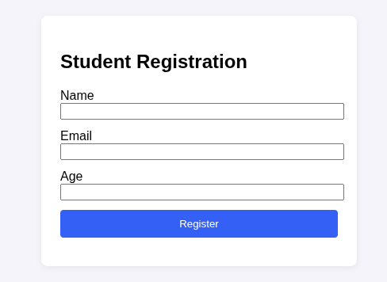

**Task-2:**

**Basic Interface:**

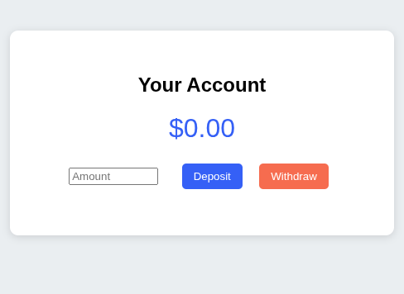

**Money Deposited:**

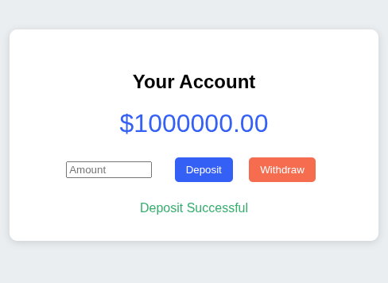

**Money Withdrawal:**

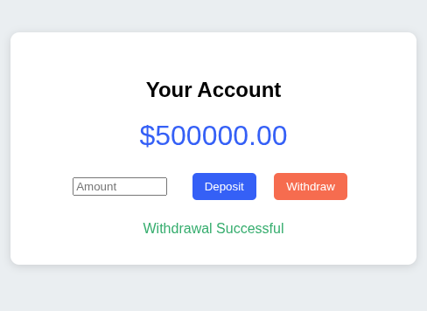

**Task-3:**

**Normal Dashboard in Default Mode:**

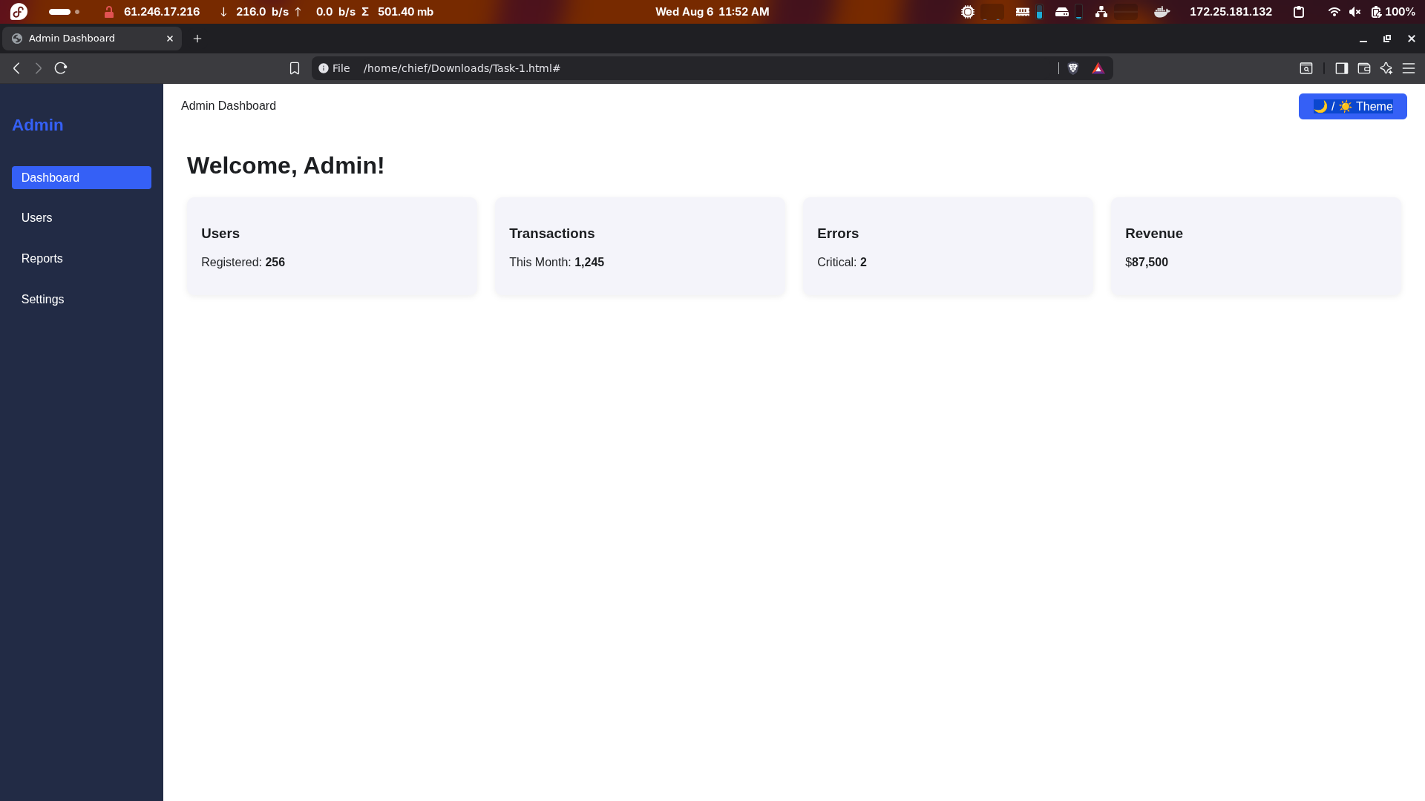

**Normal Dashboard in Dark Mode:**

